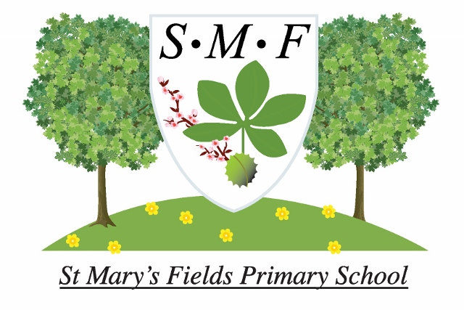
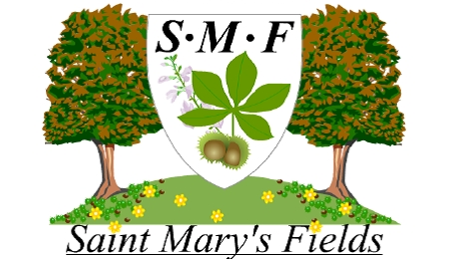

TEACHING AND LEARNING POLICY

Policy Date: | November 2018 |  | Version:
Policy Review Date: | November 2020 |  | Mrs R Dulieu (Headteacher) | Signature |  | Date
Ratified by Governing Body:
Name: Ms R Gill-Harrison |  |  | Signature |  | Date
Introduction
At St Mary’s Fields Primary School we are committed to ensuring that each child reaches their potential and develops an enthusiasm for lifelong learning. Our vision is for children to leave St. Mary’s as confident, independent, respectful and self-motivated young people, equipped with the academic, social and emotional skills to take on their next challenge.
The school policy for teaching and learning was developed after discussion with staff during the Spring Term of 2016 and has the full agreement of the governing body.

Aims
Teaching and learning are central at St Mary’s Fields Primary School. We strive to raise educational standards to help children reach their potential through a creative and exciting curriculum in a safe, secure and supporting environment.

Through our teaching we aim for our children to become:

- Reflective learners who know what they are good at, set themselves realistic goals, are resilient and learn from their mistakes;
- Independent learners who are enthusiastic, can explore and solve problems on their own and learn beyond the school environment;
- Team players who listen well and have good relationships with others, taking account of their needs;
- Self-motivators who have ambitions, are willing to try new things, show perseverance and resist distractions;
- Creative thinkers who are imaginative and are good problem solvers;
- Effective participators, who act as good role models, are tolerant and respectful of the differences and beliefs of other and positively contribute to the society they live in.

Effective teaching
Our teaching will focus on motivating the children and building on their skills, knowledge and understanding in each area of the curriculum, so that they can reach their potential.
Teachers plan a creative curriculum based around the objectives in the National Curriculum, making cross-curricular links where appropriate. In the Foundation Stage, pupils work towards the objectives in the Early Years Foundation Stage curriculum through creative and structured play.
Planning takes into account the range of pupils’ learning styles. Coherent sequences of lessons are planned to teach each subject or topic progressively. Teachers use their assessments of children’s progress and attainment to inform lesson planning. They have high expectations of all children and use differentiated planning to ensure that children of all abilities are challenged during lessons. Key reading, writing and maths skills are embedded across the curriculum.
Lessons are delivered with pace and time is used well. They have clear learning objectives that are shared with children. The tasks set are appropriate to each pupil’s level of ability and pupils are expected to develop their ability to work independently. Teaching staff review the learning of children throughout the lesson, using effective questioning to check understanding and address misconceptions where necessary. Where children are falling behind, they are well supported through differentiated work, intervention groups and one-to-one support.
Pupils are well managed and teachers insist on high standards of behaviour. Teaching staff model good learning behaviours and give opportunities for children to develop independence, resilience and perseverance.
Regular feedback, which helps pupils to make progress, is given through thoughtful marking and discussion of work with pupils. Where appropriate, homework is given to extend or complement the work done in lessons.

Effective learning
Teaching staff have good relationships with their children and understand they learn in a range of ways. They recognise the need to explore and develop strategies that allow all children to learn in ways that suit them best. We provide a rich and varied learning environment for children to learn in different ways, including:
- Investigation and problem solving;
- Open-ended tasks;
- Independent research;
- Individual, paired and group work;
- Peer teaching;
- Creating presentations;
- Drama and role play;
- Circle time;
- Class discussions;
- Use of ICT;
- Off-site visits and outdoor learning;
- Designing and making activities;
- Participation in athletic and physical activity;
- Homework;
- Extracurricular clubs;
- Guest visitors and performers.

Our children show effective learning by responding well to challenges, showing an ability to concentrate on the task set and demonstrating perseverance when the answers are not readily available. They are able to work well in different contexts, are confident and willing to ask and answer questions and enjoy their work. Children make good progress and can realistically evaluate their work and make improvements.

Monitoring and Evaluation
We believe that teaching should be conducted in an atmosphere of trust, respect and honesty. Our appraisal process uses this policy for teaching and learning as well as the OFSTED criteria to provide a clear and consistent expectation of the quality of practice across the school.
When evaluating teaching and learning in school, we make use of:
- Classroom observation;
- Data analysis;
- Analysis of pupils’ work and teachers’ feedback;
- Moderating and discussing pupils’ work with colleagues within school and with the School Development Group;
- Learning walks;
- Pupil interviews;
- Feedback from parents/carers.

Role of the Head Teacher and Governing Body
The Head Teacher and Governors monitor and review the school policies on teaching and learning. In particular they:
- Drive improvements to teaching and learning;
- Monitor the effectiveness of teaching and learning strategies in raising pupil attainment;
- Ensure that staff development and performance management policies promote high quality teaching;
- Support the use of appropriate teaching strategies by allocating resources effectively;
- Ensure that the school buildings and premises are best used to support successful teaching and learning;
- Monitor teaching strategies in the light of health and safety regulations.

Role of Parents / Carers
We believe that parents/carers have a fundamental role to play in helping children to learn. We make every effort to engage in productive dialogue, liaising with members of the wider school staff and outside agencies where necessary.
We inform parents/carers about what and how their children are learning by:
- Holding parent/carer evenings twice a year where children’s progress is discussed;
- Sending an annual written report in which children’s progress is explained;
- Providing regular homework;
- Informal, ongoing dialogue;
- Publishing documents and updates on the school website;
- Inviting parents to presentations, curriculum events and performances.
We believe that parents / carers have a responsibility to support their children and the school in the implementation of school policies.
We would like parents/carers to:
- Ensure that their child has the best attendance record possible;
- Ensure that their child is equipped for school and prepared to participate in educational activities;
- Do their best to keep their child healthy and fit to attend school;
- Inform the school it there are matters outside of school that are likely to affect a child’s performance or behaviour at school;
- Promote a positive attitude towards school and learning in general;
- Support school in the promotion of positive and appropriate behaviour.

Equality and Equal Opportunities Statement
All children have equal access and inclusive rights to the curriculum regardless of their age, gender, race, ethnicity, religion, belief, disability or ability. We plan work that is differentiated for the performance of all groups and individuals. St Mary’s Fields Primary School is committed to creating a positive climate that will enable everyone to work free from racial intimidation and harassment and to achieve their full potential. The school’s Equality Policy expands on this further.
Review
This policy will be reviewed biennially so we can take account of new research or initiatives, changes in the curriculum and developments in technology.

